**Common Data Structure Operations**

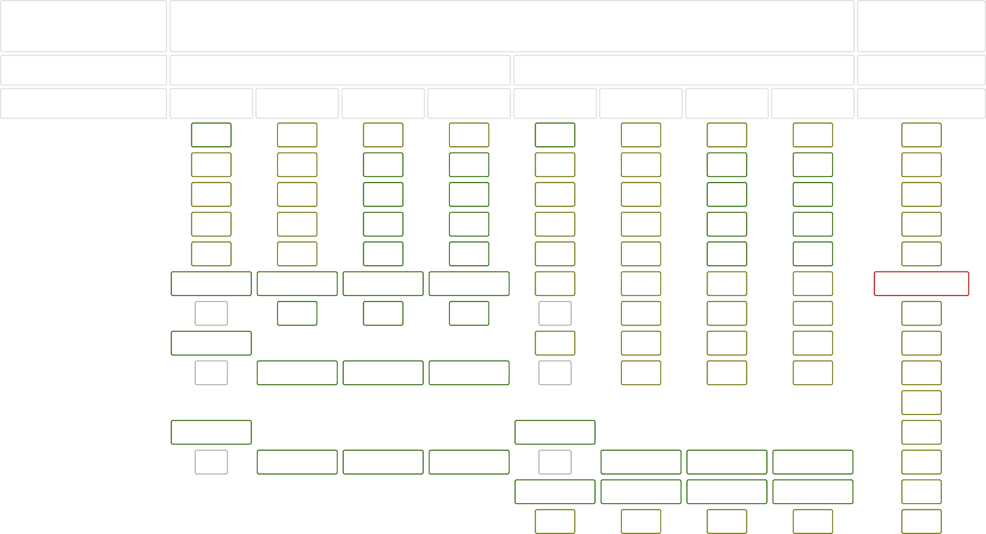

Data Structure

Time Complexity

Average

Worst

Space Complexity

Worst

|  |  |  |  |  |  |  |  |  |  |
| --- | --- | --- | --- | --- | --- | --- | --- | --- | --- |
|  | Access | Search | Insertion | Deletion | Access | Search | Insertion | Deletion |  |
| [Array](http://en.wikipedia.org/wiki/Array_data_structure) | Θ(1) | Θ(n) | Θ(n) | Θ(n) | O(1) | O(n) | O(n) | O(n) | O(n) |
| [Stack](http://en.wikipedia.org/wiki/Stack_(abstract_data_type)) | Θ(n) | Θ(n) | Θ(1) | Θ(1) | O(n) | O(n) | O(1) | O(1) | O(n) |
| [Queue](http://en.wikipedia.org/wiki/Queue_(abstract_data_type)) | Θ(n) | Θ(n) | Θ(1) | Θ(1) | O(n) | O(n) | O(1) | O(1) | O(n) |
| [Singly-Linked List](http://en.wikipedia.org/wiki/Singly_linked_list#Singly_linked_lists) | Θ(n) | Θ(n) | Θ(1) | Θ(1) | O(n) | O(n) | O(1) | O(1) | O(n) |
| [Doubly-Linked List](http://en.wikipedia.org/wiki/Doubly_linked_list) | Θ(n) | Θ(n) | Θ(1) | Θ(1) | O(n) | O(n) | O(1) | O(1) | O(n) |
| [Skip List](http://en.wikipedia.org/wiki/Skip_list) | Θ(log(n)) | Θ(log(n)) | Θ(log(n)) | Θ(log(n)) | O(n) | O(n) | O(n) | O(n) | O(n log(n)) |
| [Hash Table](http://en.wikipedia.org/wiki/Hash_table) | N/A | Θ(1) | Θ(1) | Θ(1) | N/A | O(n) | O(n) | O(n) | O(n) |
| [Binary Search Tree](http://en.wikipedia.org/wiki/Binary_search_tree) | Θ(log(n)) | Θ(log(n)) | Θ(log(n)) | Θ(log(n)) | O(n) | O(n) | O(n) | O(n) | O(n) |
| [Cartesian Tree](https://en.wikipedia.org/wiki/Cartesian_tree) | N/A | Θ(log(n)) | Θ(log(n)) | Θ(log(n)) | N/A | O(n) | O(n) | O(n) | O(n) |
| [B-Tree](http://en.wikipedia.org/wiki/B_tree) | Θ(log(n)) | Θ(log(n)) | Θ(log(n)) | Θ(log(n)) | O(log(n)) | O(log(n)) | O(log(n)) | O(log(n)) | O(n) |
| [Red-Black Tree](http://en.wikipedia.org/wiki/Red-black_tree) | Θ(log(n)) | Θ(log(n)) | Θ(log(n)) | Θ(log(n)) | O(log(n)) | O(log(n)) | O(log(n)) | O(log(n)) | O(n) |
| [Splay Tree](https://en.wikipedia.org/wiki/Splay_tree) | N/A | Θ(log(n)) | Θ(log(n)) | Θ(log(n)) | N/A | O(log(n)) | O(log(n)) | O(log(n)) | O(n) |
| [AVL Tree](http://en.wikipedia.org/wiki/AVL_tree) | Θ(log(n)) | Θ(log(n)) | Θ(log(n)) | Θ(log(n)) | O(log(n)) | O(log(n)) | O(log(n)) | O(log(n)) | O(n) |
| [KD Tree](http://en.wikipedia.org/wiki/K-d_tree) | Θ(log(n)) | Θ(log(n)) | Θ(log(n)) | Θ(log(n)) | O(n) | O(n) | O(n) | O(n) | O(n) |

**Array Sorting Algorithms**

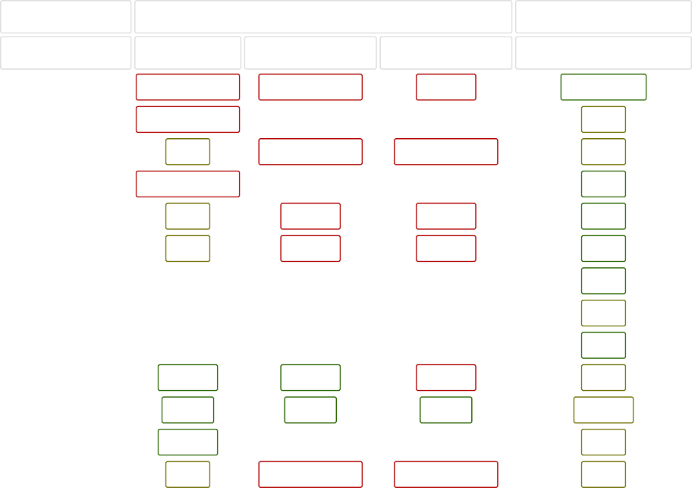

Algorithm

Time Complexity

[Quicksort](http://en.wikipedia.org/wiki/Quicksort) [Mergesort](http://en.wikipedia.org/wiki/Merge_sort) [Timsort](http://en.wikipedia.org/wiki/Timsort) [Heapsort](http://en.wikipedia.org/wiki/Heapsort) [Bubble Sort](http://en.wikipedia.org/wiki/Bubble_sort) [Insertion Sort](http://en.wikipedia.org/wiki/Insertion_sort) [Selection Sort](http://en.wikipedia.org/wiki/Selection_sort) [Tree Sort](https://en.wikipedia.org/wiki/Tree_sort) [Shell Sort](http://en.wikipedia.org/wiki/Shellsort) [Bucket Sort](http://en.wikipedia.org/wiki/Bucket_sort) [Radix Sort](http://en.wikipedia.org/wiki/Radix_sort) [Counting Sort](https://en.wikipedia.org/wiki/Counting_sort)

[Cubesort](https://en.wikipedia.org/wiki/Cubesort)

Best

Ω(n log(n))

Average Worst

Θ(n log(n)) O(n^2)

Space Complexity Worst

O(log(n))

Ω(n log(n))

Θ(n log(n))

O(n log(n))

O(n)

Ω(n)

Θ(n log(n))

O(n log(n))

O(n)

Ω(n log(n))

Θ(n log(n))

O(n log(n))

O(1)

Ω(n)

Θ(n^2)

O(n^2)

O(1)

Ω(n)

Θ(n^2)

O(n^2)

O(1)

Ω(n^2)

Θ(n^2)

O(n^2)

O(1)

Ω(n log(n))

Θ(n log(n))

O(n^2)

O(n)

Ω(n log(n))

Θ(n(log(n))^2)

O(n(log(n))^2)

O(1)

Ω(n+k)

Θ(n+k)

O(n^2)

O(n)

Ω(nk)

Θ(nk)

O(nk)

O(n+k)

Ω(n+k)

Θ(n+k)

O(n+k)

O(k)

Ω(n)

Θ(n log(n))

O(n log(n))

O(n)